**Hardware Components**

The hardware components of the computer system are the parts of the computer that can be handled physically. They are the basic part upon which the computer software runs. Unlike the software which can be modified, created, or deleted, the hardware part of the computer are changed infrequently. Because they are physical, they are susceptible to damages. Hence, the reason they are changed.

**Computer hardware** includes the physical parts of a [computer](https://en.wikipedia.org/wiki/Computer), such as the [case](https://en.wikipedia.org/wiki/Computer_case), [central processing unit](https://en.wikipedia.org/wiki/Central_processing_unit) (CPU), [monitor](https://en.wikipedia.org/wiki/Computer_monitor), [mouse](https://en.wikipedia.org/wiki/Computer_mouse), [keyboard](https://en.wikipedia.org/wiki/Computer_keyboard), [computer data storage](https://en.wikipedia.org/wiki/Computer_data_storage), [graphics card](https://en.wikipedia.org/wiki/Graphics_card), [sound card](https://en.wikipedia.org/wiki/Sound_card), [speakers](https://en.wikipedia.org/wiki/Computer_speakers) and [motherboard](https://en.wikipedia.org/wiki/Motherboard)

**The Motherboard**  
The name "Motherboard" is very suitable for this hardware. It is a circuit board – the computer's main circuit board that contains different components that are soldered and non-removable, as well as the removable ones with slots or sockets. It is the part of the computer that houses the CPU chips, and the ROM and RAM chips, etc.

**Central Processing Unit (CPU)**  
The CPU is like the computer's brain that takes instructions and works on them. It applies the program instructions to the input data then turns it into an output. There are two components of the CPU. These are the Arithmetic and Logic Unit (ALU) and the Control Unit.

* The Arithmetic and Logic Unit is the part of the CPU responsible for executing the instructions. It is able to convert data to diverse internal formats, as well as compare data, multiply and add numbers, etc.
* The Control Unit is responsible for "housekeeping." It ensures the swift processing of the instructions in its proper sequence and only works on correct data
* **Monitor/ Display Screen**  
  This is an essential part of the computer as it is the part that users relate to the most. It is an output device that works just the same as a TV and basically shows the users' activities on the screen. Monitors vary among different computers in both resolution and size. The screen size varies from sizes as small as 12 -14 inches to the bigger 40+ inches used for video conferences. The difference in the resolution also depends on different technical factors.
* **The Keyboard**  
  This is an important input device on the computer system. It is one means by which information can enter the computer. This information is usually displayed first on the computer's monitor. The keyboard has a layout similar to the typewriter which was modeled after. While the QWERTY layout of the keyboard was designed to slow down the typewriter operator to prevent the keys from getting stuck it is now counter-productive on computers being able to process the input faster
* **The Mouse – Pointing Device**  
  The mouse is another input device that is essential for moving and pointing on the monitor. The outer part is plastic molded and the bottom has a small bat. It is designed so that it fits right into the palm and can be moved easily by the hand. The small ball at the bottom rolls as the mouse is moved over a flat surface. This movement corresponds with the pointer or cursor which is seen on the monitor.
* The mouse also has two buttons – the right and left buttons – which can be used for showing menu items, selecting icons, or tracing drawings on the monitor. The trackball in between the two mouse buttons also does the work of the mouse. It can be manipulated to move the cursor on the monitor without having to move the mouse around a surface.
* **Random Access Memory (RAM)**  
  The RAM is made up of silicon microchips with millions of small transistors. It is very similar to the CPU chips in this regard and the technology is based on the Law of Moore. One chip of a RAM can hold up hundreds of Megabyte. These chips are pre-soldered on some memory circuit boards known as SIMMS or DIMMS (Single/Dual In-line Memory Modules).
* There are two types of RAM: Cache memory which operates at the same speed with the CPU and Flash RAM which is made of RAM chips. It is not as volatile as the normal RAM and can hold content even in the absence of external power.
* **Read-only memory (ROM)**  
  The ROM is also made of electronic microchips and is able to retain its content when power switches off. ROM is used for holding program instructions that can't be changed throughout the life of the computer because the content of ROM is impossible or very difficult to remove. For instance, ROM is used mainly for storing a boot program which is the instructions that the computer follows to perform self-diagnosis when it's switched on. This tells the computer how it will load the OS from secondary storage.
* ROM has different forms which include PROM (Programmable Read-Only Memory), EPROM (Erasable Programmable Read-Only Memory,) and EEPROM (Electrically Erasable Programmable Read-Only Memory).
* **Printers and plotters**  
  These are output devices that are popular for producing computer output that is permanent and paper-based. There is a distinction which divides printers into two types: impact printers and non-impact printers. Impact printers use a needle or hammer hitting the inked ribbon so that it leaves the desired impression on the paper. But non-impact printers do not have many parts moving mechanically, so they are more reliable and also much quieter.
* There are different types of printers that are in use currently. They are Dot-matrix printers, Laser printers, Thermal printers, Inkjet printers, plotters, chain, and line printers.
* **Power Supply**  
  This is a device that takes power to the different components of the computer as its name suggests. The outer case has a voltage control, transformer, and a fan. It is responsible for supplying low-voltage DC power to the different internal components of the computer, which converts from 100-120 volts of AC power. This power supply is usually built in a way that conforms to the ATX form factor. With this, it is enabled to interchange with other components in the computer.

**Specification of buying a PC**

With the power of modern hardware, they can even provide a decent computing experience without completely draining your wallet. The trick is in finding the right balance between cost and your needs.

**RAM**

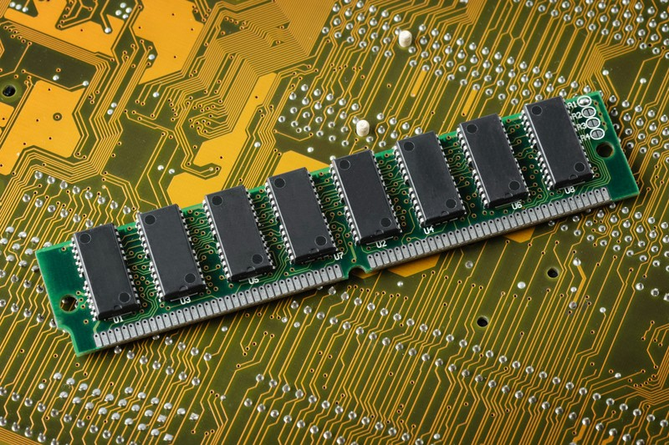

RAM is short for Random Access Memory. Not to be confused with storage, RAM is where active data from your applications and system processes are stored. Think of RAM as the temporary canvas or scratchpad where a computer does its real-time calculations and operations.

With today’s memory-hungry applications and web browsers, computers need more RAM than ever before. If you tend to use multiple open apps at the same time, then the more RAM your computer has, the better.

With enough RAM, you can run more applications simultaneously and have more open browser tabs before your computer bogs down.

Although Windows 10 requires a minimum of 1GB  on 32-bit and 2GB on 64-bit (macOS requires 2GB minimum), that’s not nearly enough for a smooth experience. If you’re shopping around for a new computer, always go for at least 8GB of RAM. If you’re planning on multitasking and doing more on your computer than everyday tasks, shoot for at least 16GB.

### ****Processor****

### https://www.komando.com/wp-content/uploads/2018/09/CPU.jpg

Processors keep getting more efficient and powerful with each yearly upgrade, but Intel always has easily recognizable performance tiers to choose from, depending on your needs.

As usual, Intel’s entry-level Core i3 chips are the cheapest but least powerful processors available. If you’re looking for a sub-$500 computer that will do basic computing tasks, then the Core i3 line should be ample enough.

The mid-range Core i5 chips are suitable for people who want a good balance between performance and cost. If you’re on a budget but you still need ample speed for power usage, shoot for a computer with an i5 chip, at least.

Computers with Core i7 and i9 chips are more expensive, but professionals who don’t have the time for loading and rendering screens will appreciate the power that these processors bring to the table. If money is no object and you’re looking for the absolute best computer you can buy, don’t settle for anything less than a Core i7 chip.

Also, keep in mind that the latest generation chips are typically more powerful and efficient than their predecessors. For example, Intel’s current 8th generation chips have at least four cores so they’re faster (but less power-hungry) than their equivalent 7th generation counterparts.

### ****Storage****

### https://www.komando.com/wp-content/uploads/2018/09/SSD.jpg

Currently, there are two types of computer storage types to choose from:  HDD (hard disk drive) and SSD (solid state drive).

HDDs still use rapidly spinning magnetic disks called “platters” to store information while SSDs use flash memory (similar to what smartphones and tablets use).

Computers with SSDs are more expensive but their read and write rates are much faster than computers with conventional HDDs. SSDs don’t have moving parts too so they’re lighter, cooler, quieter, more efficient and are harder to damage than a conventional drive.

With these advantages, always choose a computer with an SSD over one with a conventional hard drive. They might be more expensive but their speed and efficiency are definitely worth the difference.

Some computers combine the best of both worlds with hybrid drives. These combine a small SSD and a large HDD in a single package. While hybrids aren’t as fast as a true SSD, they are less expensive and hold more. Of course, as SSD prices continue to drop and sizes increase, hybrids will eventually disappear.

On the other hand, storage capacity depends on your needs. As usual, the bigger the drive, the more expensive a computer will be. The good news is that you can always expand your storage space with a memory card, external drive or even replace the entire drive if needed. You could also use cloud storage in addition to your local drive.

### ****Screen Size****

### https://www.komando.com/wp-content/uploads/2018/09/Screen-Size.jpg

Screen size is mostly a decision you’ll have to make if you’re buying a laptop. Laptop displays typically range between 11 and 17 inches and if you’re planning on running multiple windows, the extra screen real estate will make a big difference.

However, keep in mind that the bigger the screen, the less portable a laptop will be. Bigger screen laptops will also have less battery life, so take that into consideration when choosing one.

With desktops, portability and battery life obviously doesn’t matter but most people choose 24-inch or larger monitors.

### ****Resolution****

### https://www.komando.com/wp-content/uploads/2018/09/resolution.jpg

It all depends on your preferences (and budget), but no matter what the size, your display’s resolution will determine how sharp your screen will appear.

Most budget laptops only come in 720p, decent enough for smaller display sizes, but aim for at least a 1080p (1920 x 1080) display.

High-end computers typically come with Ultra HD/4K displays but as usual, they are more expensive.

### ****Size and weight****

Obviously, the size and weight of desktops don’t matter that much, but for laptops, portability can be a big factor. Lugging around a big and heavy laptop can be a hassle, so if you’re planning on taking your laptop with you all the time, pick one that has a 13-inch screen or smaller.

Looking for the ultimate in portability? Some high-end laptops called ultra books can be amazingly slim and light. However, if you’re on a budget and still prefer performance over portability, a thicker and heavier laptop will typically give you more bangs for your buck.

### ****Operating system****

You’ve had a question on your mind for years, maybe even decades: PC or Mac? The good news is that both operating systems have improved over the years and it just depends on how you’re using your PC or laptop. If you ask me, the line between the two operating systems keeps blurring with each update.

Creative professionals have traditionally used Macs for years and they tend to stick with the programs that they’re familiar with, so Apple computers are more popular with video and graphics editors. If you’re deep in the Apple ecosystem and use an iPhone, iPad or Apple Watch, you’ll also appreciate how all these gadgets work together.

However, you can get a similarly spec’d PC for a much lower price point and that’s one thing that Windows machines have — cost. Windows is still widely used in the workplace too and a lot of people are comfortable with it. Again, it all depends on what programs and user interfaces you prefer.

Alternatively, if you feel adventurous, you can explore other operating systems like the Chrome OS on Chrome books or even Linux.

### ****Connectivity****

There are tons of connection options nowadays and they keep evolving, so it can be quite confusing. To future proof your purchase; look for USB-C, USB 3.1 ports and at least 801.11AC on the Wi-Fi side.

Computers with these options may be more expensive but you’ll be set for years to come. And as usual, the more ports a computer have, the better.

### ****Price****

At the end of the day, it still all boils down to how much you’re willing to spend. If you’re only planning on using your computer to browse the web, send emails, and watch the occasional video, then you can get away with a cheaper computer. Remember, nowadays, even the cheapest ones are powerful enough to run everyday tasks.

If you will depend on your computer for work, aim for at least a mid-ranged one. They might cost more, but you’ll appreciate the speed and the time you’ll save. As a general rule, the better the performance, the more expensive a computer will be. Assess your budget and how you’ll be using your machine, hopefully with these tips, you’ll find the right balance between price and performance.